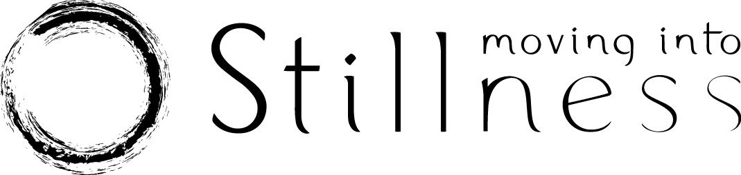

COVID-19 Supplementary Questionnaire

This form is supplementary to the Moving Into Stillness Health Questionnaire, which must
already have been completed.

Your Name:

Your Current Address:
Home Address (if different):
Email Address:
Mobile Phone Number:
Date of Birth:

About you and COVID-19
 |  | YES | NO
1 | Have you had, or suspect you have had COVID-19 Coronavirus?
2 | If yes, when?
3 | If yes, was this diagnosed by means of a positive test result?
4 | Have you attended the emergency department or been admitted to hospital due to COVID-19 symptoms?
 | If you have answered yes to question 4, has your doctor given you permission to exercise?
5 | Are you still experiencing symptoms post COVID-19?  If yes, please list them:

More about you
 |  | YES | NO
6 | Are you an NHS front line worker?
7 | Are you a carer in a care home?
8 | Are you considered to be at extra risk (i.e. clinically vulnerable)?
9 | Do you have a family member who is vulnerable or extremely vulnerable?
10 | Are you pregnant?  If yes, how many weeks?
11 | Are you allergic to specific cleaning products?  If yes, please give details:

**IMPORTANT SAFETY ADVICE**

If you have a fever, a new and continuous cough, a loss of taste or smell or are feeling unwell, please do not come to class:

If a member of your household has any of the above symptoms and is waiting for a test, please self-isolate and do not attend class until the results are known.

Please also do not come to class if you have any of the following symptoms and these are new or unexplained:
- Shortness of breath; fatigue; muscle aches and pains; loss of appetite; sore throat; nasal congestion; headache; diarrhoea; nausea and vomiting.

If you have knowingly been in close contact with anyone who has tested positive for Covid-19 in the last 14 days, please do not attend class until 14 days from that contact have elapsed.

For more advice visit the NHS Coronavirus Service:
https://www.nhs.uk/conditions/coronavirus-covid-19 or call 111 for advice.

DECLARATION

I confirm that the above information is accurate and give consent for my contact details to be given to NHS Test and Trace should this be required.
I have read and understood the ‘Important Safety Advice ’ and will contact my teacher about any future change in circumstances.
Please enter your full name below to confirm that you have read and legally agreed to the declaration above

Your Name:

Date:

Thank you for completing this form. The details you have provided will only be shared with NHS Track and Trace if necessary, otherwise the form will be stored in line with the Moving Into Stillness Privacy Policy.

Please complete and return this form to yoga@movingintostillness.co.uk before your first in-person class.

